127th JFES News Letter | https://www.spwla-jfes.org/  Email: info@spwla-jfes.org
Japan Formation Evaluation Society, Japan Chapter of SPWLA | May 2026

- 129th JFES Chapter Meeting

The 129th JFES Chapter Meeting was held on March 17th, 2026, hosted by JAMSTEC (Japan Agency for Marine Earth Science and Technology). We welcomed 17 in-person attendees and more than 30 online audiences.

Presentation 1
<Title> Capturing Spatiotemporal Changes After the 2011 Tohoku-Oki Earthquake: Insights from the Japan Trench Drilling Projects (JFAST and JTRACK)
<Speaker> Yohei Hamada (JAMSTEC)

Presentation 2
<Title> Integrated true color borehole image: finding formation property changes within the image
<Speaker> Chiaki Morelli (SLB)

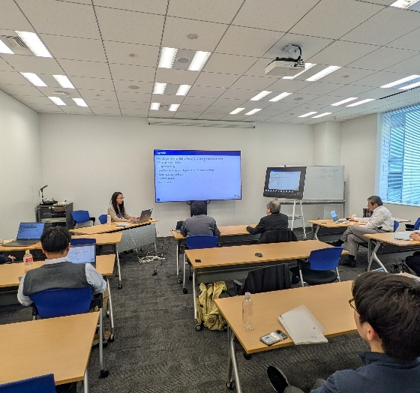 | 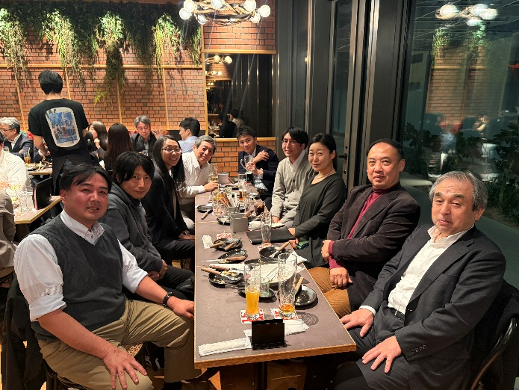
Lively discussion during the Chapter meeting | Informal Icebreaker with presenters

- JFES Annual Symposium 2026 – Call for Abstracts

We are currently organizing the 2026 JFES Annual Symposium, scheduled to take place from October 7th to 9th, 2026. We are seeking enthusiastic Technical Committee Members who are willing to volunteer their time to review technical papers and participate in discussions about conference operations. If you are interested, please contact us at the following address: info@spwla-jfes.org
Many authors responded to our Call for Abstract (deadline for April 14th, 2026), and based on the paper submissions, we expect to select an interesting and exciting program for all the attendees. Topics of the Symposium will be:
- Geomechanics (Special theme)
- Formation Evaluation of conventional and unconventional reservoirs
- New technology/advanced of logging and sampling
- New technology in subsurface (geophysical, geological, petrophysical and reservoir)
- Case Studies from oil & gas, geothermal, new energy, CCUS, geo-engineering, and scientific drilling

For registration and abstract submission, please use the following link: https://forms.office.com/e/iYBd4fyxG3

- Upcoming events: 2026 Distinguished lecture event (online only)

Our Distinguished Lecture will be held on 16th April 2026. More than 50 people registered for this online event, and we expect positive feedback from our audience.

Time and Date: 16:00-17:00(JST) 16th April 2026

Presentation
<Title> Advanced Logging Techniques for Characterizing a Complex Turbidite Reservoir in the Norwegian Sea
<Speaker> Andrew Mburu (Harbour Energy)

END

