128th JFES News Letter | https://www.spwla-jfes.org/  Email: info@spwla-jfes.org
Japan Formation Evaluation Society, Japan Chapter of SPWLA | July 2026

- 2026 Distinguished lecture at JFES

Our Distinguished lecture was held in April 16th, 2026. More than 60 people from Energy & Service companies and university attended this online event and we received high appreciation regarding the topic of the lecture. We deeply appreciate Dr. Andrew Mburu for his contribution to our annual activities.

Presentation
<Title> Advanced Logging Techniques for Characterizing a Complex Turbidite Reservoir in the Norwegian Sea
<Speaker> Andrew Mburu (Harbour Energy)

- JFES Annual Symposium 2026

We are currently organizing the 2026 JFES Annual Symposium, scheduled to take place from October 7th to 9th, 2026. We are seeking enthusiastic Technical Committee Members who are willing to volunteer their time to review technical papers and participate in discussions about conference operations. If you are interested, please contact us at the following address: info@spwla-jfes.org
Many authors responded to our Call for Abstract, and after abstracts review in early May, 23 abstracts were selected for oral presentation. Due to the large number of abstracts received, we decided to hold a Poster session to allow authors to present their results. Based on the content of oral and poster presentations, we expect to prepare an interesting and exciting program for all the attendees.
Topics of the Symposium will be:
- Geomechanics (Special theme)
- Formation Evaluation of conventional and unconventional reservoirs
- New technology/advanced of logging and sampling
- New technology in subsurface (geophysical, geological, petrophysical and reservoir)
- Case Studies from oil & gas, geothermal, new energy, CCUS, geo-engineering, and scientific drilling

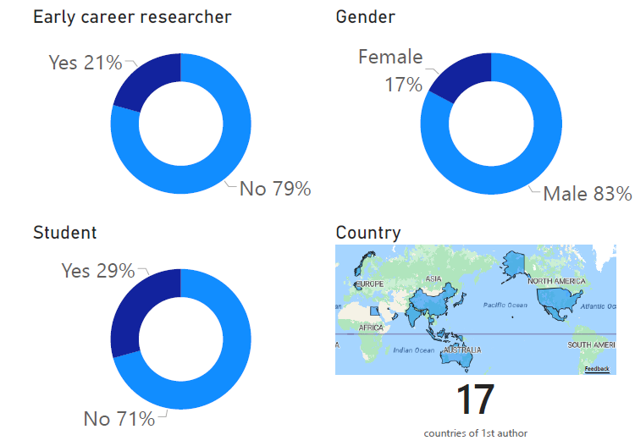

Overview of abstract submissions for the JFES Annual Symposium 2026

- Upcoming events: 130th JFES Chapter Meeting

Our 130th JFES Chapter Meeting will be held on 15th July 2026 in hybrid format, sponsored by Taisei Corporation. We expect a large attendance and positive feedback from our audience.

Time and Date: 15:30-17:00(JST) 15th July 2026

Presentaion 1
<Title> Hydraulic fracturing of granite for harvesting superhot geothermal energy
<Speaker> Ryota GOTO (Taisei Corporation)

It has traditionally been assumed that, in deep subsurface environments hosting superhot geothermal resources (>400 °C), fracture permeability is significantly reduced due to the brittle–ductile transition of rocks. However, recent experimental and theoretical studies suggest that this conventional view may be incomplete.
In this study, we investigate fracture formation and permeability evolution through water injection experiments on granite conducted at temperatures exceeding 400 °C, designed to simulate hydraulic fracturing under superhot geothermal conditions. The results demonstrate that interconnected networks of microcracks can develop even in high-temperature regimes, forming permeable fracture pathways.
We present the mechanisms governing the initiation, growth, and linkage of these microcracks, and discuss the resulting structural characteristics of the fracture networks. These findings provide new insights into permeability enhancement in superhot geothermal systems and have important implications for the development and exploitation of next-generation geothermal resources.

Presentation 2
<Title> Numerical Perspectives on Tide-Induced Pressure Responses for Supplementary CCS
Monitoring
<Speaker> Toshifumi AKAKI (Taisei Corporation)

The use of tidal-induced pore pressure fluctuations has been proposed as a supplementary monitoring technique for carbon capture and storage (CCS). In this study, we focus on small pore pressure variations in reservoirs induced by Earth tides and ocean tides and investigate the effects of CO₂ injection on their amplitude and phase through numerical modeling.
Using data from the Otway CCS Project, including pressure responses attributed to Earth tides, we apply a coupled hydro-mechanical simulation framework based on poroelastic theory to reproduce pressure variations associated with the presence and migration of the CO₂ plume. The analysis captures how CO₂ injection alters the characteristics of tidal pressure signals within the reservoir.
Through these investigations, we evaluate the potential of tidal response analysis to improve understanding of CO₂ plume behavior and to serve as an effective supplementary monitoring approach for CCS operations.

Presentaion 3
<Title> Cost and social benefit analysis for a carbon capture and storage project
<Speaker> Atsuhiro MIYAGI (Taisei Corporation)

Carbon Capture and Storage (CCS) is a climate change mitigation technology that involves capturing CO₂ emissions from sources such as thermal power plants and storing them in deep geological formations, including sandstone reservoirs. Numerous CCS projects are currently being planned worldwide.
For the implementation of CCS, it is essential to conduct cost–benefit analyses to support economically sound decision-making, including project selection and prioritization. In this study, we define the social benefit of a CCS project as the monetary value of avoided climate change damages attributable to CO₂ storage. Based on this definition, we perform a cost–benefit analysis of a representative CCS project and present the results.

END

